1. P, Q and R were partners sharing profits in the ratio of 2 : 2 : 1. The firm closes its books on March 31 every year. On June 30, 2017, R died. The following information is provided on R’s death:
(i) Balance in his capital account in the beginning of the year was Rs. 6,50,000.
(ii) He withdrew Rs. 60,000 on May 15, 2017 for his personal use. On the date of death of a partner the partnership deed provided for the following:
(a) Interest on capital @ 10 % per annum.
(b) Interest on drawings @ 12 % per annum.
(c) His share in the profit of the firm till the date of death, to be calculated on the basis of the rate of Net Profit on Sales of the previous year, which was 25 %. The Sales of the firm till June 30, 2017 were Rs. 6,00,000.
Prepare R’s Capital Account on his death to be presented to his executors
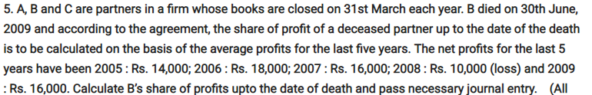
3. At what rater is interest payable on the amount remaining unpaid to the executor of deceased partner.[2]
4. Name the account which is opened to credit the share of profit of the deceased partner, till the time of his death to his capital account. [2]
5. State any two deductions that may to be made from the amount payable to the lExecutor of deceased partner.[2]

